
19/12/2025
Name: Shruti Kaladagi
KU No: k2452322
CI7330: Data Analytics and Visualisation
Employee Satisfaction Data Analysis Report Assignment 1

1: Describe the age profile of the workforce.

R output:
summary(employees$Age)
Min. 1st Qu. Median Mean 3rd Qu. Max.
18.00 30.00 36.00 36.92 43.00 60.00
sd(employees$Age, na.rm = TRUE)
[1] 9.135373

Visualisation: Box Plot
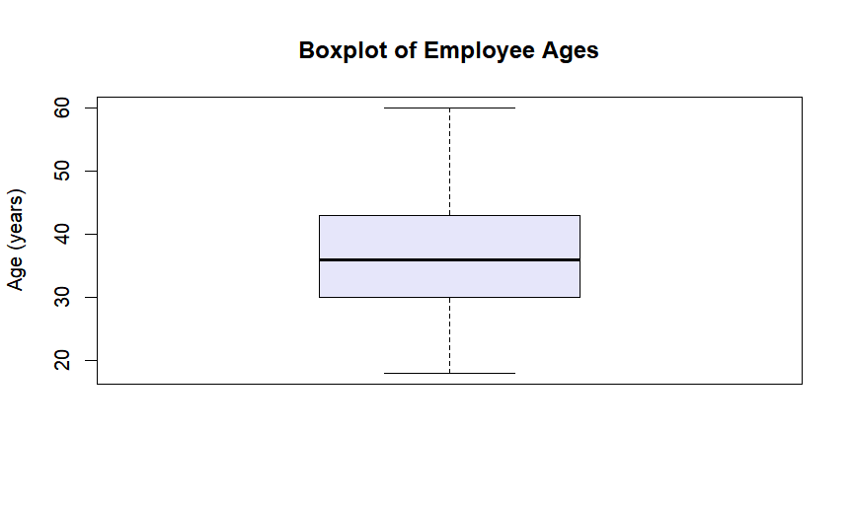

Summary:
Employee ages range from 18 to 60 years, with a mean age of 36.9 and a median of 36. The interquartile range (30–43 years) indicates that the majority of employees fall within early to mid-career stages. The boxplot suggests a broadly balanced age distribution with moderate variability and no extreme outliers.
2: Describe the average monthly incomes of employees
R output:
summary(employees$incomeGBP)
Min. 1st Qu. Median Mean 3rd Qu. Max.
504.5 1455.5 2459.5 3251.5 4189.5 9999.5
mean(employees$incomeGBP, na.rm = TRUE)
[1] 3251.466

Visualisation: Violin Plot
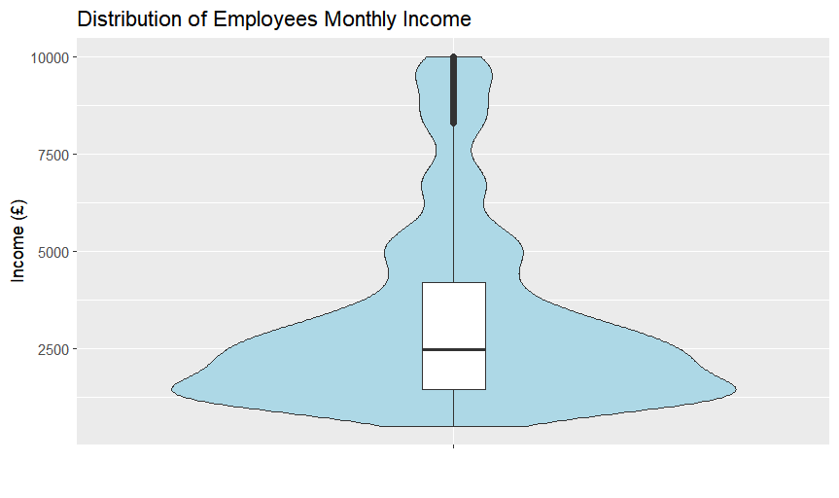

Summary:
Monthly income varies considerably across employees, ranging from £504 to £9,999. The mean monthly income (£3,251) exceeds the median (£2,460), indicating a positively skewed distribution. The violin plot highlights that most employees earn within the lower to middle income ranges, while a smaller proportion receive substantially higher salaries.
3: Describe average distances employees travel to work
R output:
summary(employees$distance)
Min. 1st Qu. Median Mean 3rd Qu. Max.
1.000 2.000 7.000 9.193 14.000 29.000

Visualisation: Histogram
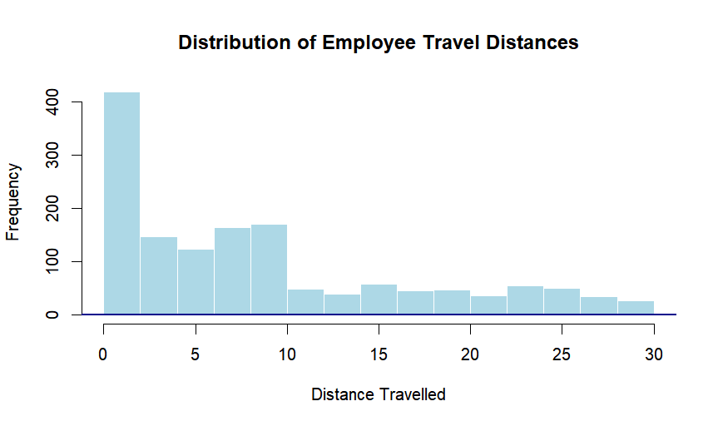

Summary:
Employees report commuting distances between 1 and 29 units, with an average distance of 9.19 and a median of 7. Most employees travel relatively short distances, as reflected by the interquartile range of 2 to 14. The histogram indicates a right-skewed distribution, suggesting that long commutes are less common. The dataset does not specify the unit of measurement for distance, therefore results are interpreted in relative terms.

4: Describe employees educational backgrounds.

R output:

table(employees$education_factor)

No formal qualifications 5+ GCSEs A level or equivalent
170 282 572
HE degree Post degree qualification
398 48
prop.table(table(employees$education_factor)) * 100

No formal qualifications 5+ GCSEs A level or equivalent
11.564626 19.183673 38.911565
HE degree Post degree qualification
27.074830 3.265306
##summary statistics
which.max(table(employees$education_factor))
A level or equivalent

Visualisation: Bar plot
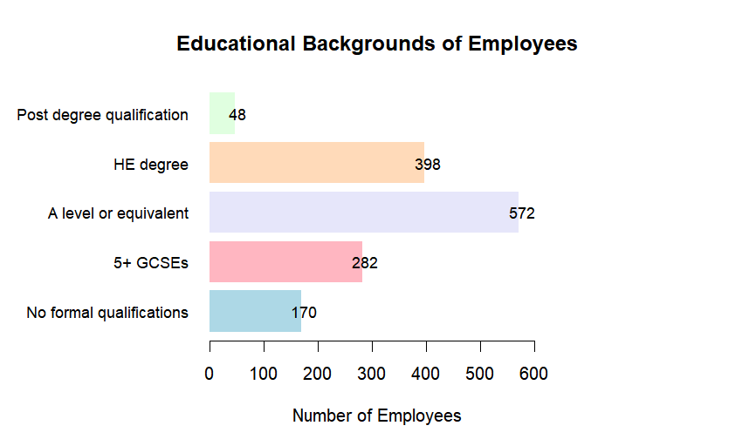

Summary:
Educational attainment varies across the workforce. The largest proportion of employees hold A-level or equivalent qualifications (38.9%), followed by HE degrees (27.1%). Employees with 5+ GCSEs represent 19.2%, while smaller proportions have no formal qualifications (11.6%) or postgraduate qualifications (3.3%). Overall, the workforce demonstrates a predominance of intermediate to higher educational attainment.

5: Explore incomes by age.

R output:

Correlation Test:

Pearson's product-moment correlation
data: employees$Age and employees$incomeGBP
t = 21.995, df = 1468, p-value < 2.2e-16
alternative hypothesis: true correlation is not equal to 0
95 percent confidence interval:
0.4583951 0.5353551
sample estimates:
cor
0.4978546

Pearson correlation result indicates as age increases, monthly income tends to increase as well.

Visualisation: Scatterplot

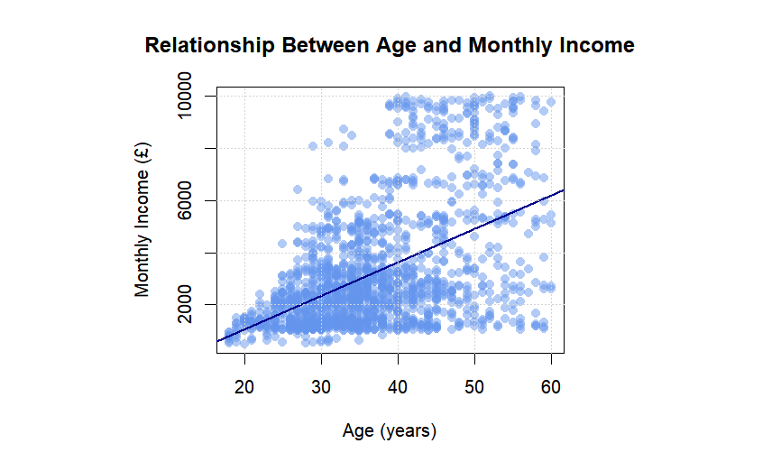

Interpretation:
The scatterplot demonstrates a clear positive association between age and monthly income, with older employees generally earning more. Pearson’s correlation coefficient (r = 0.497) indicates a moderate positive relationship, which is statistically significant (p < 2.2e−16). This suggests that income tends to increase with age within the organisation.

Conclusion
There is a meaningful upward trend showing that monthly income tends to increase with age within the workforce.

6: Explore incomes between the sexes.

Visualisation: Boxplot
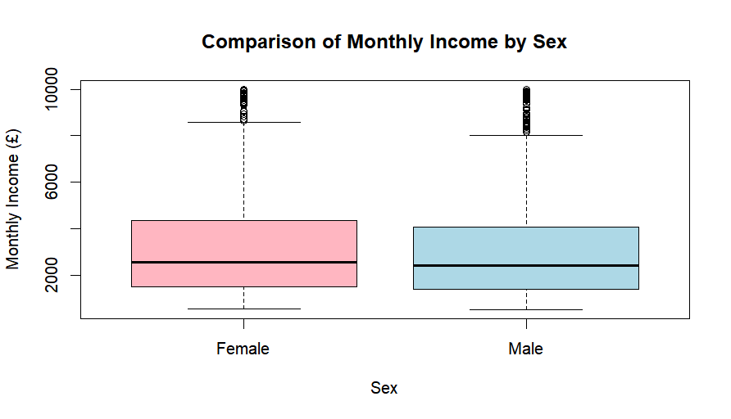

Income distributions for male and female employees appear similar, with comparable medians and overlapping interquartile ranges. The Welch two-sample t-test found no statistically significant difference in mean monthly income between sexes (p = 0.2218). Although female employees have a slightly higher mean income, this difference is not statistically meaningful.

Hypotheses:
- Null hypothesis (H₀): There is no significant difference in mean monthly income between male and female employees.
- Alternative hypothesis (H₁): There is a significant difference in mean monthly income between male and female employees.

Statistical Test:
A Welch two-sample t-test was used to compare mean monthly
Income between male and female employees.

R output:
Welch Two Sample t-test

data: incomeGBP by Sex
t = 1.2223, df = 1261.5, p-value = 0.2218
alternative hypothesis: true difference in means between group Female and group Male is not equal to 0
95 percent confidence interval:
-92.59715 398.65554
sample estimates:
mean in group Female mean in group Male
3343.283 3190.254

Interpretation of Results:
The p-value of 0.2218 exceeds the 0.05 significance level, indicating no statistically significant difference in mean monthly income between sexes. The 95% confidence interval includes zero, further supporting this conclusion. Although females have a slightly higher mean income, this difference is not statistically significant.

Decision and Conclusion:
The null hypothesis is not rejected. There is no evidence of a statistically significant difference in average monthly income between male and female employees in this dataset.

7: Explore incomes by education.

Visualisation: Boxplot

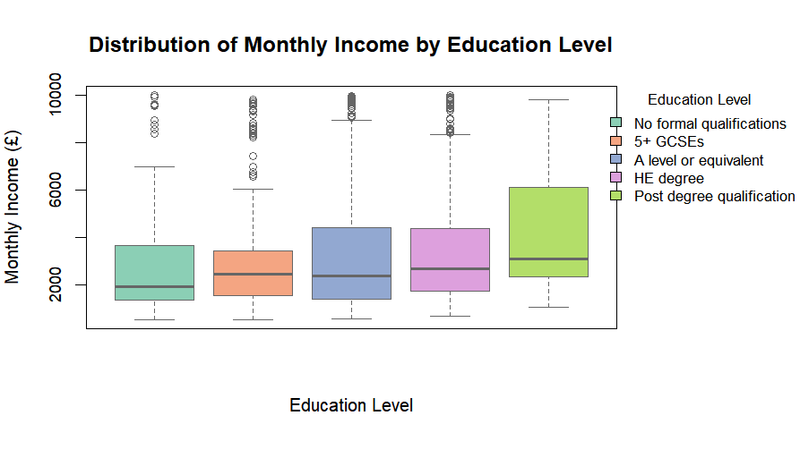

Monthly income generally increases with higher levels of educational attainment. Employees holding, HE and postgraduate qualifications exhibit higher median incomes and greater income variability. One-way ANOVA results confirm a statistically significant difference in mean income across education groups (F(4,1465) = 3.893, p = 0.00377).

Hypotheses:
- Null hypothesis (H₀):
Mean monthly income is the same across all education levels.
- Alternative hypothesis (H₁):
At least one education group has a different mean monthly income.

Statistical Test:
A one-way ANOVA was conducted to compare mean monthly income across the different education groups.

ANOVA output:
Df Sum Sq Mean Sq F value Pr(>F)
education_factor 4 8.561e+07 21403220 3.893 0.00377
Residuals 1465 8.054e+09 5497905

ANOVA results and Interpretation:
The ANOVA results indicate that statistically significant effect of education level on monthly income (F (4,1465) = 3.893, p = 0.00377). Since the p-value is less than 0.05, the null hypothesis is rejected. This indicates that mean monthly income differs significantly between at least one pair of education groups.

Post-hoc Analysis:
A post-hoc test was conducted because ANOVA only indicates that a difference exists somewhere among the education groups. The Tukey HSD test was used to identify which specific education levels differ significantly in mean income.
Key findings:
Tukey post-hoc comparisons reveal that employees with HE degrees earn significantly more than those with no formal qualifications (p = 0.044). Employees with postgraduate qualifications earn significantly more than those with no formal qualifications (p = 0.005) and those with 5+ GCSEs (p = 0.041). No other pairwise comparisons show statistically significant differences.
Conclusion:
Overall, the findings suggest that higher educational attainment is associated with higher monthly income. In particular, employees with HE and postgraduate qualifications earn significantly more than those with lower levels of education.

8: Explore job satisfaction by sex and educational background.
(i) Job Satisfaction by Sex:
1. Crosstabulation and Percentages:

table_JS_sex <- table(employees$Jobsatisfaction, employees$Sex)
table_JS_sex

Female Male
1 119 170
2 118 162
3 181 261
4 170 289
prop.table(table_JS_sex, margin = 2) * 100

Female Male
1 20.23810 19.27438
2 20.06803 18.36735
3 30.78231 29.59184
4 28.91156 32.76644

>

Interpretation:
The above crosstabulation shows similar distributions of job satisfaction across males and females. In both groups, the largest proportions of employees report job satisfaction levels of 3 or 4. Males show a slightly higher proportion in the highest satisfaction category (32.8%) compared to females (28.9%).

2. Hypotheses:
• Null hypothesis (H₀):
Job satisfaction is independent of sex.
• Alternative hypothesis (H₁):
Job satisfaction differs by sex.

3.Statistical Test:
A Pearson’s Chi-squared test of independence was used to examine the relationship between job satisfaction and sex.

R output:
Pearson's Chi-squared test
data: table_JS_sex
X-squared = 2.5477, df = 3, p-value = 0.4667

Interpretation:
The test was not statistically significant (χ²(3) = 2.5477, p = 0.4667). This indicates no evidence of a significant association between sex and job satisfaction.

Conclusion:
Overall, job satisfaction levels do not differ significantly between male and female employees. Any observed differences in satisfaction distributions are small and likely due to random variation.

(ii) Job Satisfaction by Education:
1. Crosstabulation and percentages
table_JS_edu <- table(employees$Jobsatisfaction, employees$education_factor)
table_JS_edu

No formal qualifications 5+ GCSEs A level or equivalent HE degree
1 32 52 118 74
2 26 54 128 67
3 56 83 161 127
4 56 93 165 130

Post degree qualification
1 13
2 5
3 15
4 15

prop.table(table_JS_edu, margin = 2) * 100

No formal qualifications 5+ GCSEs A level or equivalent HE degree
1 18.82353 18.43972 20.62937 18.59296
2 15.29412 19.14894 22.37762 16.83417
3 32.94118 29.43262 28.14685 31.90955
4 32.94118 32.97872 28.84615 32.66332

Post degree qualification
1 27.08333
2 10.41667
3 31.25000
4 31.25000

Interpretation:
The distribution of job satisfaction is broadly similar across education groups. Across all education levels, the highest proportions of employees report moderate to high job satisfaction (levels 3 and 4). Employees with HE degrees and postgraduate qualifications show slightly higher proportions of high satisfaction, but differences are modest.

2. Hypotheses:
- Null hypothesis (H₀):
Job satisfaction is independent of education level.
- Alternative hypothesis (H₁):
Job satisfaction differs across education levels.
3. Statistical Test:
A Pearson’s Chi-squared test was used to assess the association between job satisfaction and education level.

R output:
chisq.test(table_JS_edu)

Pearson's Chi-squared test

data: table_JS_edu
X-squared = 13.03, df = 12, p-value = 0.3669

Interpretation:
The test result was not statistically significant (χ²(12) = 13.03, p = 0.3669), indicating no significant association between education level and job satisfaction.

Conclusion
There is no statistical evidence to suggest that job satisfaction differs significantly across education levels. Job satisfaction appears relatively consistent regardless of employees’ educational background.

